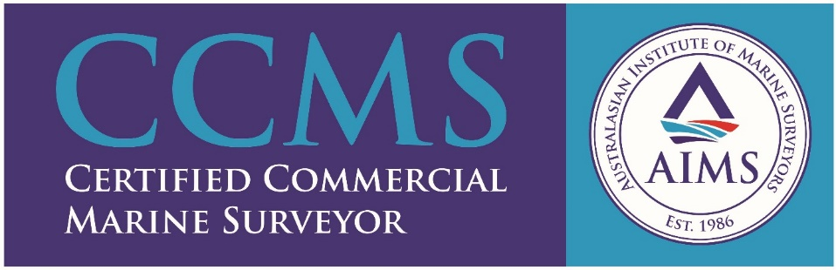

PLUMLEY PEARSON & WHITE

The company was established in Brisbane in 1917, and since then has provided general and specific Marine Surveying and Advisory Services of high quality and integrity to the Shipping Industry.

We are well acquainted with all aspects of the safe carriage of General, Heavy Lift, Containerised, Refrigerated and Dry Bulk Cargoes and the associated stevedoring practices. We have extensive experience of the Bulk Oil, Chemical, Liquid Component Trades.

We are Preferred Surveyors to P & I Clubs, and Hull and Machinery Underwriters, and their correspondents; we regularly undertake work through their various legal representatives.

As professional seamen, we have the qualifications and accumulated experience to investigate all manner of marine incidents and, from time to time, are called upon to provide technical advice on matters where litigation is pending or threatened.

The Company regularly undertakes consultative work for Port Authorities, Shipping Companies and the Oil and Mining Industries, as well as providing ISM advice and Audit services to the Marine Industry.

The Company is Quality Endorsed to ISO 9001 by SAI Global. Our Policy and Quality Management System precludes the use of subcontractors thereby guaranteeing competent, professional representation.

