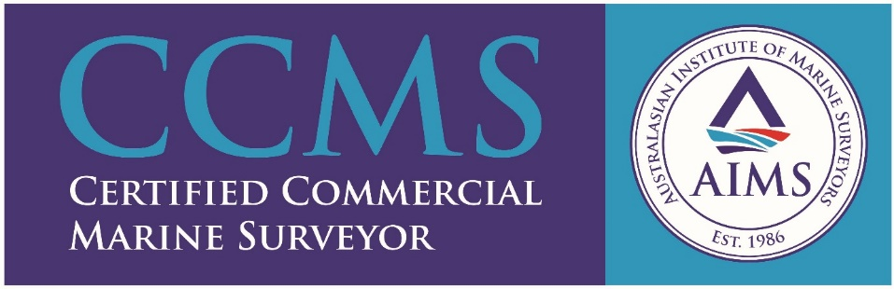

Marine Consulting and Survey Pty Ltd
MCS is a South Australian consulting and survey company with global operating capabilities, which can provide a vast range of services, and is committed to providing the highest quality service in a timely manner. MCS has the capability to survey vessels ranging from domestic commercial vessels (DCV) through to large foreign-going ships.
MCS has a close working relationship with naval architects and with construction engineers who are able to provide assistance and back up to the services we can provide.

