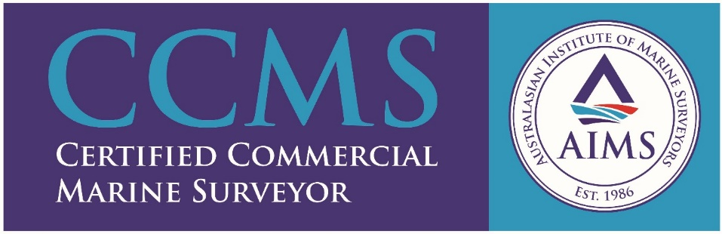
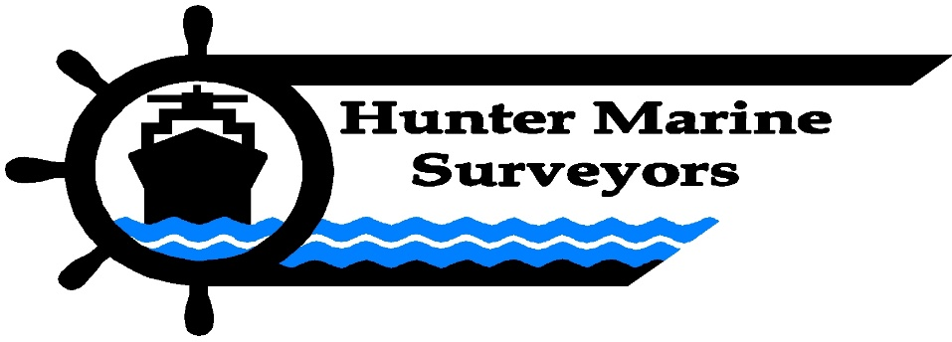
HUNTER MARINE SURVEYORS – Company Profile
Hunter Marine Surveyors is an ISO Accredited company dedicated to providing a complete and comprehensive service in all forms of marine surveying.
Our mission is to "Provide an ever-evolving service that meets the requests of our clients today and forward into the future" . By keeping pace with technology, we can provide high quality surveying services and products. Utilising advances in information technology means faster reporting to our clients.
​We have many diverse clients who have been with us for a long time. The reason for our long term and strengthening relationship with our customers is that they all deserve and obtain our individual customised service. This business focus ensures our new clients get the same standard of service and attention to detail.
Our professionalism and team standards ensures the highest quality of service. Our in-house training and review system ensure that we learn from each job as a team, sharing knowledge and improve our systems continuously. This practice brings the highest quality and most consistent service to all of our clients.

Contact Details
Phone: +61 2 49426748
Fax: +61 2 49426708
Email: surveyors@huntermarine.com.au
Address: U11 / 5 Frost Drive, Mayfield West, NSW, 2304

